

**Rajshahi University of Engineering and Technology**

**Department of Electrical and Electronic Engineering**

**Course No. :** EEE 3200

**Course Name :** Electrical and Electronic Circuit Simulation Lab

**Experiment No. :** 07

**Experiment Name :** Introductionclass object & Performing Different Tasks Using class of jupyter notbook

|  |  |
| --- | --- |
| Submitted by,  **Shovon kumar Ray**  Roll :1910141  Section:c  Series:19 | Submitted to,    **Dr. Mohammod Abdul Motin**  Assistant Professor  Dept. of EEE  RUET |

Date of Experiment : Decenber04 , 2023

Date of Submission : December 11, 2023

**Experiment No. :** 07

**Name of The Experiment :** Gaining knowledge about class object & Performing Different Tasks Using class of jupyter notbook

**Objectives:**

* To obtain knowledge class object
* To perform several tasks involving the class

**Theory:**In Python, a class is a blueprint for creating objects. Objects are instances of classes, and classes define attributes (characteristics) and behaviors (methods or functions) that the objects can have.Class: A class is a blueprint or a template for creating objects. It defines the attributes (data) and methods (functions) that the objects of the class will have.

Object: An object is an instance of a class. It represents a real-world entity and has attributes (characteristics) and methods (behaviors).

Task : Write a program using class to display name,age profession

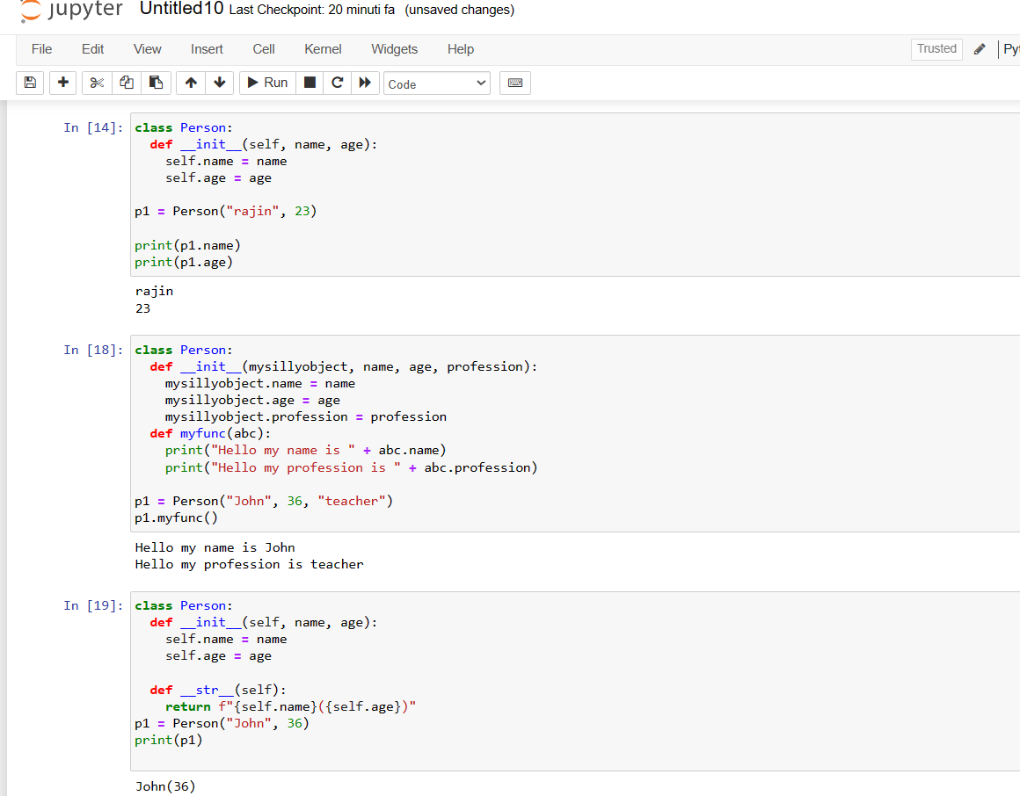

Task: Create a class called Rectangle to represent rectangles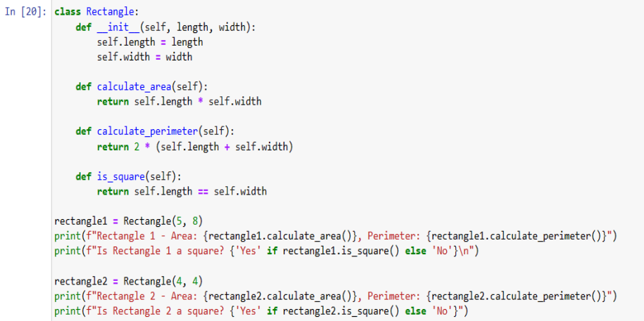

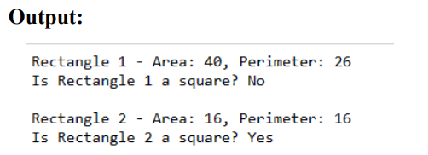

Task: Performing the class object but output function can’t work outside of class 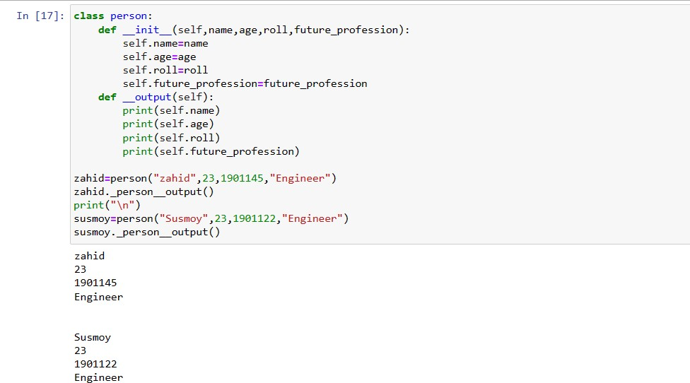

**Discussion & Conclusion:** The Rectangle class serves as a shining example of object-oriented programming brilliance, embodying the essence of rectangles by encapsulating both their properties and behaviours. This class boasts a modular design that not only calculates the area, perimeter, and checks for squareness but does so with an elegance that promotes code reusability and readability. Beyond its geometric roots, the versatility of the Rectangle class extends into realms of graphics, visualization, and data modeling. Its design stands as a testament to adaptability, offering a scalable solution for various scenarios. The principles of abstraction and polymorphism gracefully unfold within the class, gracefully abstracting away implementation intricacies. This abstraction empowers users to interchangeably employ methods for different instances, fostering a harmonious code experience